

|  |  |
| --- | --- |
| **Style No.** FRLT06[FR06LT]  Foro Ceiling Flush Mount Large With Glass Shade | **Style No.** FRLT05 [FR05LT]  Foro Ceiling Flush Mount Small With Glass Shade |
| fb3d14f3d5ed016b4266a801195f645 | fb3d14f3d5ed016b4266a801195f645 |
| * All items in [BRACKETS] refer to UK styles | | |
|  | | |

**SPECIFICATIONS:**

Bulb Base Size: E26 [E27]

Bulb Type for FRLT06[FR06LT]/FRLT05 [FR05LT]: A19

Junction Box Orientation: any

Junction Box Size for FRLT06[FR06LT]/FRLT05 [FR05LT]: 3-3/5” X 3/3/5” swith type

Max Wattage for FRLT06[FR06LT]: 100 Watt

Max Wattage for FRLT05 [FR05LT: 60 Watt

Orientation for FRLT06[FR06LT]/FRLT05 [FR05LT] :Ceiling Only

Shade Material: Glass

Voltage: 120 [220]

Required Electrical Feeds:

US: Black “Hot” wire; White “Neutral” wire; Green or Bare“Ground” wire

UK: [Brown “Line” wire; Blue “Neutral” wire; Green/Yellow Striped or Bare “Earth” wire]

**IMPORTANT:**

* WARNING: The power supply must be turned off prior to installation. Turn off the main electrical supply to the junction box from the fuse box/circuit breaker. Turning power off at the switch is not sufficient.
* To ensure this product is installed properly, you must read and follow these guidelines.
* The owner/user of this product must keep this information for future reference.
* FR06LT and FR05LT are U.L. certified and are suitable for dry locations. The U.L. listing mark can be found on the inside of the cover plate.
* FRLT06 and FRLT05 are CE rated. Proof of CE compliance will be provided upon request.
* Be sure your installation conforms to all federal, state, and local codes.
* This product must be installed by a professional licensed electrical contractor.
* Refer to the specification and assembly drawings attached. Product is sold partially assembled but shown fully disassembled for illustrative and service purpose only.
* Max wattage for FRLT06 [FR06LT] is 100 watts for incandescent A19 base light bulbs. Max wattage for FRLT05 [FR05LT] is 60 watts for incandescent A19 base light bulbs.

**FRLT06 [FR06LT] Ceiling INSTALLATION:**

* REQUIRED: Install a Outlet Box electrical junction box at the desired height.
* See Figure - 01 for Steps 1 - 2.

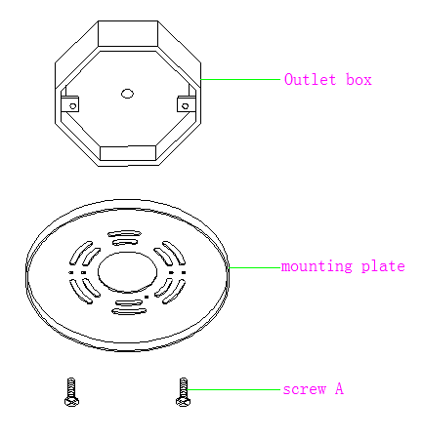

FIGURE – 01

1. Install an outlet box(3-3/5” X 3-3/5” switch type) vertical mounting, making sure to use supply connection wire that meets local codes.
2. Install the mounting plate to wall outlet box by using 2pcs screw A provided.

* See Figure - 02 for Step 1.

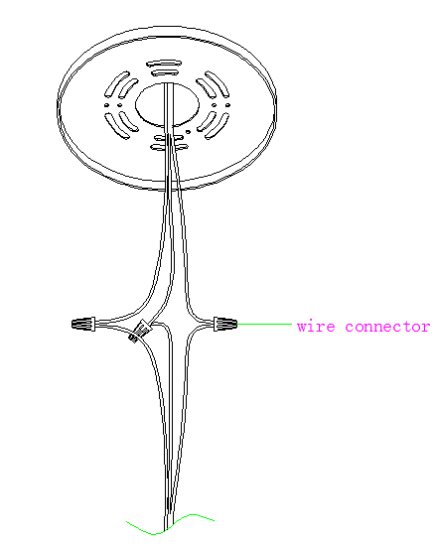

FIGURE – 02

1. Connect the wires from the fixture to the wires in the outlet box as shown in figure 02.

* See Figure - 03 for Step 1-2.

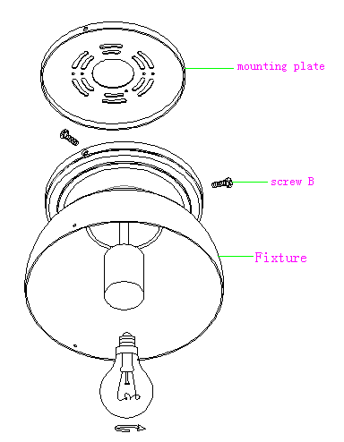

FIGURE – 03

1. Install the fixture body to the mounting plate using 3pcs screw B provided.
2. Install the 100 watts max A19 standard bulb(not included) into the fixture body.

* See Figure - 04 for Steps 1.

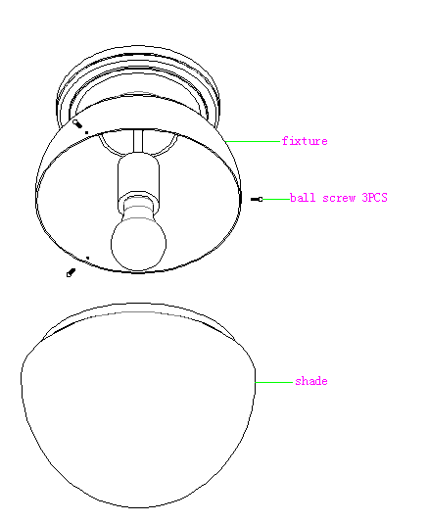

FIGURE – 04

1. Install the glass shade into the fixture body and lock it with 3pcs ball screws provided.

**FRLT05 [FR05LT] Ceiling INSTALLATION:**

* REQUIRED: Install a Outlet Box electrical junction box at the desired height.
* See Figure - 01 for Steps 1 - 2.



FIGURE – 01

1. Install an outlet box(3-3/5” X 3-3/5” switch type) vertical mounting, making sure to use supply connection wire that meets local codes.
2. Install the mounting plate to wall outlet box by using 2pcs screw A provided.

* See Figure - 02 for Step 1.



FIGURE – 02

1. Connect the wires from the fixture to the wires in the outlet box as shown in figure 02.

* See Figure - 03 for Step 1-2.



FIGURE – 03

1. 1. Install the fixture body to the mounting plate using 3pc
2. screw B provided.
3. 2. Install the 60 watts max A19 standard bulb(not i included) into the fixture body.

* See Figure - 04 for Steps 1.



FIGURE – 04

1. Install the glass shade into the fixture body and lock it with 3pcs ball screws provided.