FIG 7

|  |  |
| --- | --- |
| **Style No. HNLT05 [HN05LT]**  Wall Mounted Single Sconce with Fabric Shade |  |
|  |  |

**SPECIFICATIONS:**

Bulb Base Size: E12 [E14]

Bulb Type: Candelabra

Junction Box Orientation: Any

Junction Box Size: Standard 4: Octagon

Max Wattage: 60 Watt

Orientation: Wall Only

Shade Material: Fabric

Voltage: 120 [240]

Required Electrical Feeds:

UL: Black “Hot” wire; White “Neutral” wire; Green or Bare

“Ground” wire

CE: [Brown “Line” wire; Blue “Neutral” wire; Green/Yellow Striped or Bare “Earth” wire]

**IMPORTANT:**

* WARNING: The power supply must be turned off prior to installation. Turn off the main electrical supply to the junction box from the fuse box/circuit breaker. Turning power off at the switch is not sufficient.
* To ensure this product is installed properly, you must read and follow these guidelines.
* The owner/user of this product must keep this information for future reference.
* HNLT05 is U.L. certified and are suitable for damp or dry locations. The U.L. listing mark can be found on the inside of the cover plate. [HN05LT] is CE rated. Proof of CE compliance will be provided upon request.
* Be sure your installation conforms to all federal, state, and local codes.
* This product must be installed by a professional licensed electrical contractor.
* Refer to the specification and assembly drawings attached. Product is sold partially assembled but shown fully disassembled for illustrative and service purpose only.
* Max wattage for HNLT05 [HN05LT] is 60 watts for incandescent E12 [E14] base light bulbs.

**HNLT05 [HN05LT] SCONCE INSTALLATION:**

* REQUIRED: Install a Gem Box electrical junction box at the desired height.
* See Figure - 01 for Steps 1 - 6.

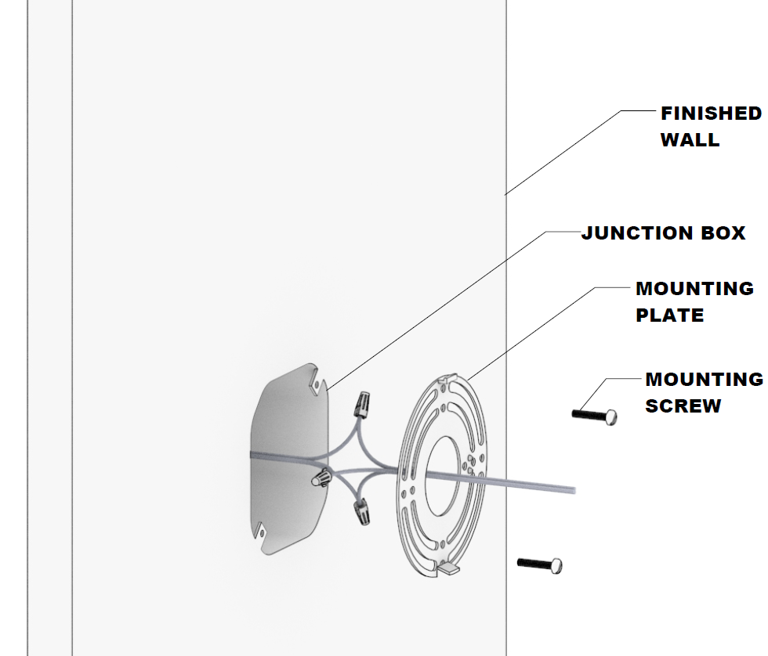

FIGURE – 01

1. Remove the MOUNTING PLATE by unthreading the SET SCREW from the back plate.
2. Pull the wires from the light through the center of the MOUNTING PLATE.
3. Fasten the bare copper fixture wire to the green or bare copper wire in the box with a wire nut or fasten it to the MOUNTING PLATE with the ground screw provided.
4. Fasten the white fixture wire to the white wire in the box with a wire nut. Tightly wrap the connection with electrical tape beginning 1” [25mm] below the wire nut to ensure the tape seals the end of the nut. Make sure that there are no exposed wires that could cause a short circuit.
5. Repeat previous step with the black fixture wire and the black wire from the junction box. Make sure the wires are pushed into the junction box.
6. Attach the MOUNTING PLATE to the JUNCTION BOX using the MOUNTING SCREWS making sure to keep the proper alignment of the plate.

* See Figure - 02 for Step 7.

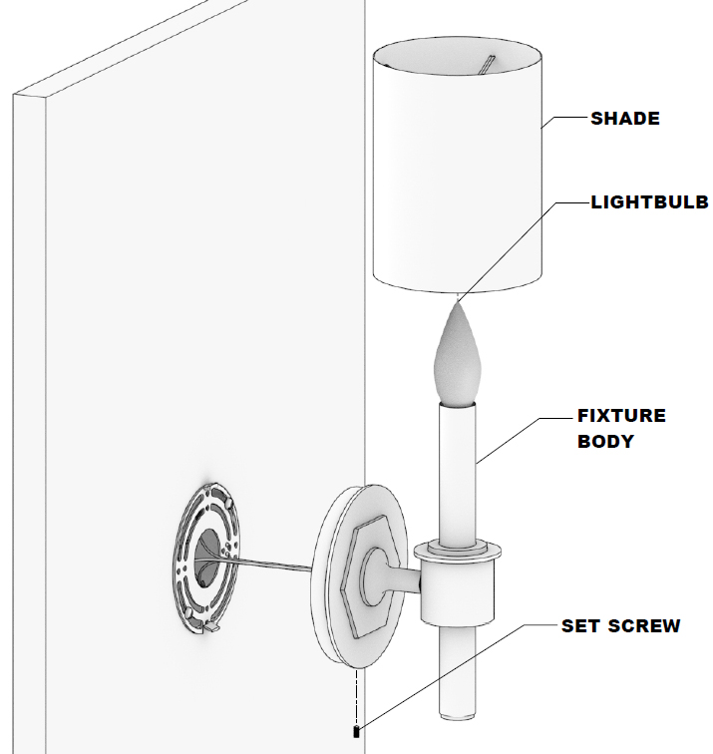

FIGURE – 02

1. Use the SET SCREW to secure the FIXTURE BODY to the wall.
2. Secure the SHADE to the LIGHT ASSEMBLY by placing over lightbulb.

**SERVICING THE LIGHT:**

1. Lift the Shade up to gain access to the BULB for cleaning and servicing.

* If further assistance is required, please contact Product Support at 1-800-927-2120 (8am-6pm EST).